Problem Statement:
AWS Cost Optimization: Identifying Stale Resources
Identifying Stale EBS Snapshots
In this example, we'll create a Lambda function that identifies EBS snapshots that are no longer associated with any active EC2 instance and deletes them to save on storage costs.
A Step-by-step guide:
Description:
The Lambda function fetches all EBS snapshots owned by the same account ('self') and also retrieves a list of active EC2 instances (running and stopped). For each snapshot, it checks if the associated volume (if exists) is not associated with any active instance. If it finds a stale snapshot, it deletes it, effectively optimizing storage costs.
Assume that a developer working in an Organisation has started taking snapshots of a volume attached to an EC2 instance every day for one month to back up the data stored in volumes.

- Create an EC2 instance
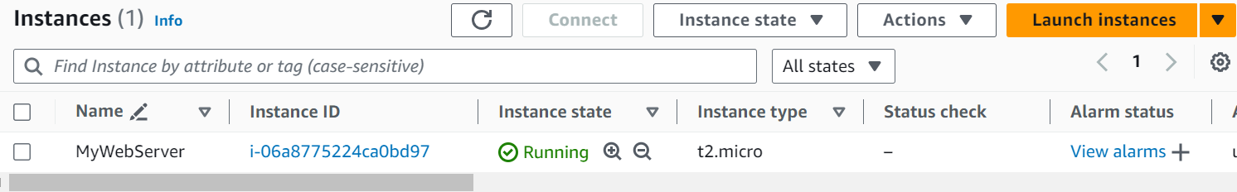

- Go to EC2 Dashboard -> Volumes. A volume has been created which is attached to the EC2 instance
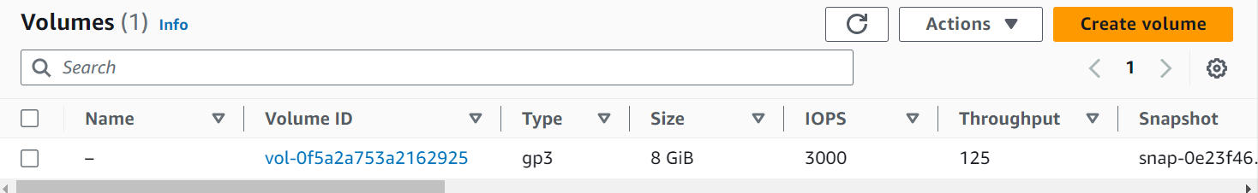

- Go to Ec2 Dashboard -> Snapshots and click Create snapshot
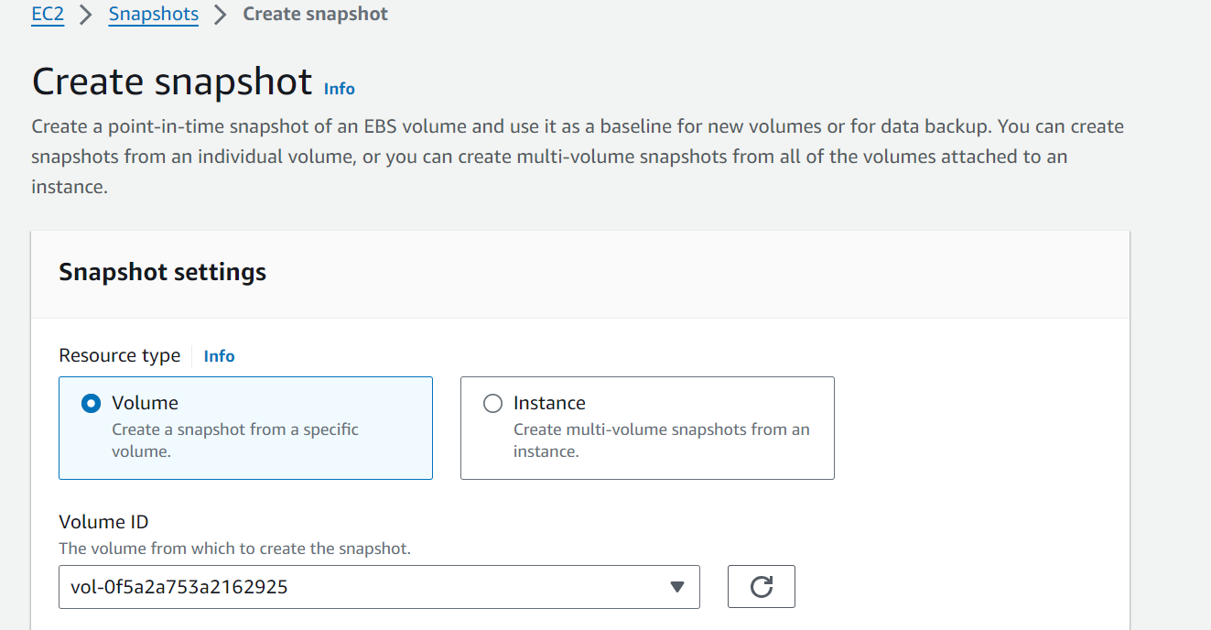
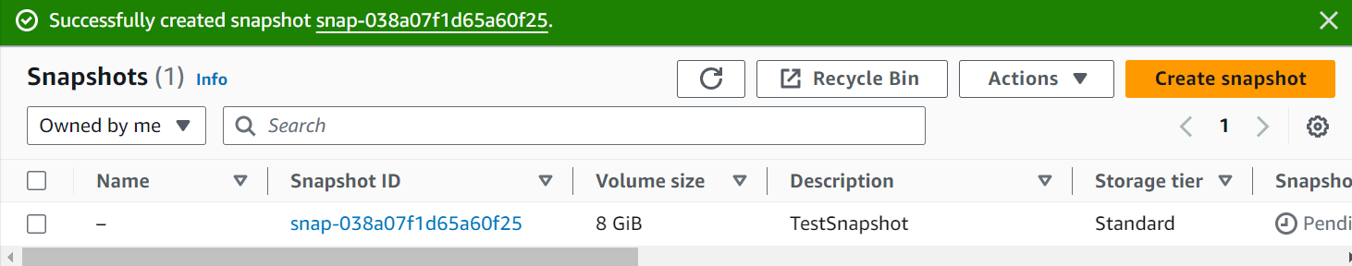
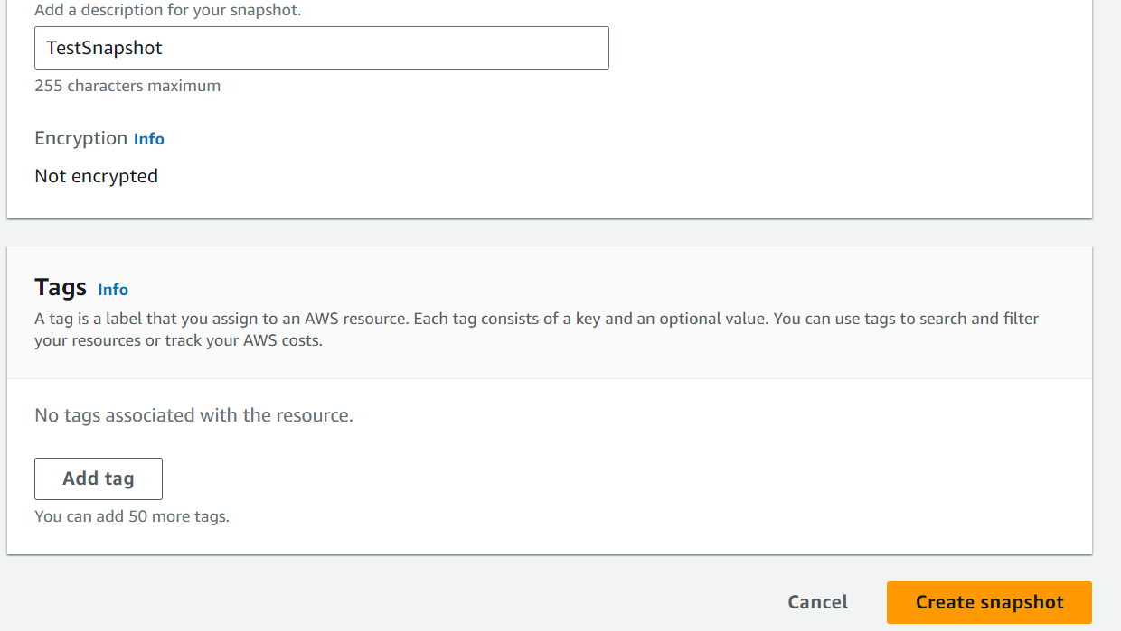

- Now assume that the developer deleted the EC2 instance and corresponding volumes but forgot to delete the snapshots which he has been creating since one month. In such cases use Lambda function to delete the snapshots and save the cost for the organization
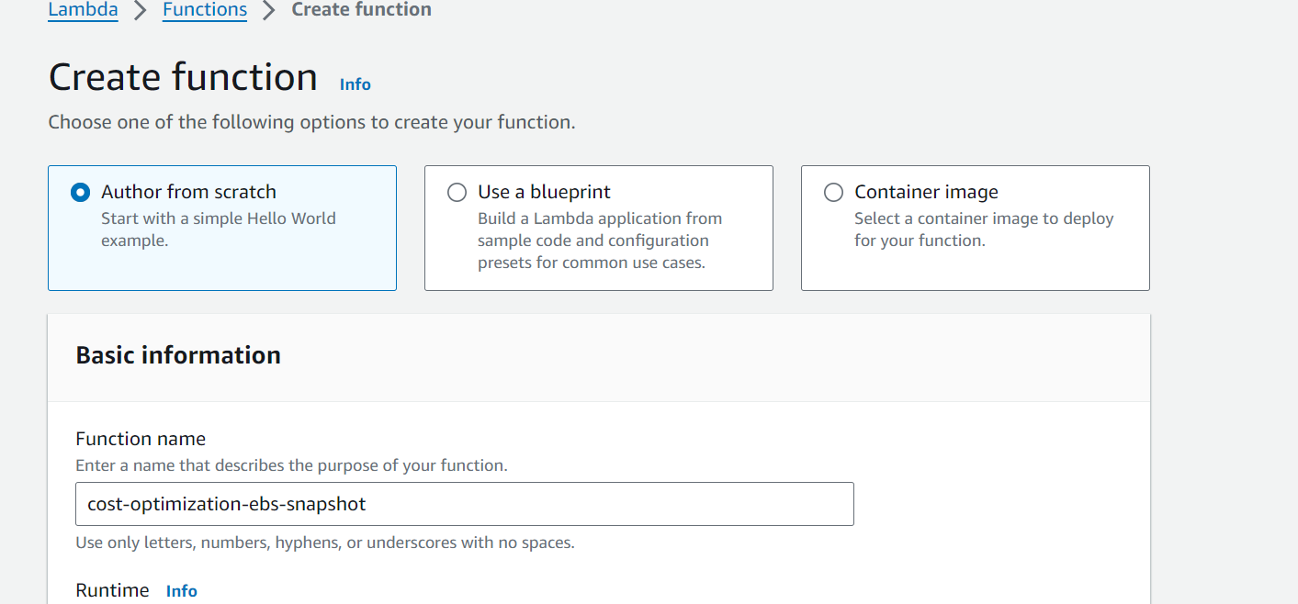
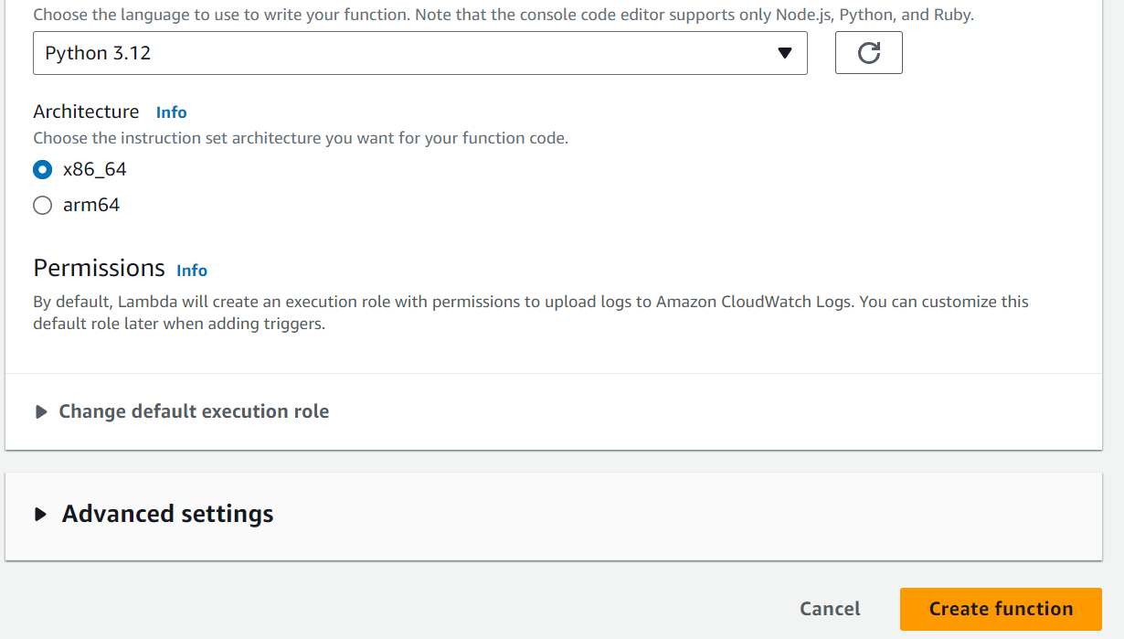
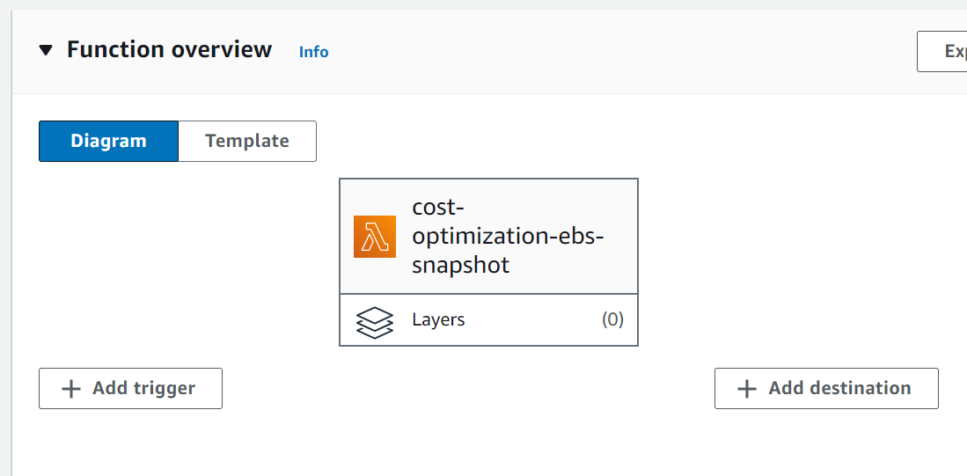

- Paste the code at the following location in the lamda_function. Save and click Deploy

https://github.com/iam-veeramalla/aws-devops-zero-to-hero/blob/main/day-18/ebs_stale_snapshosts.py

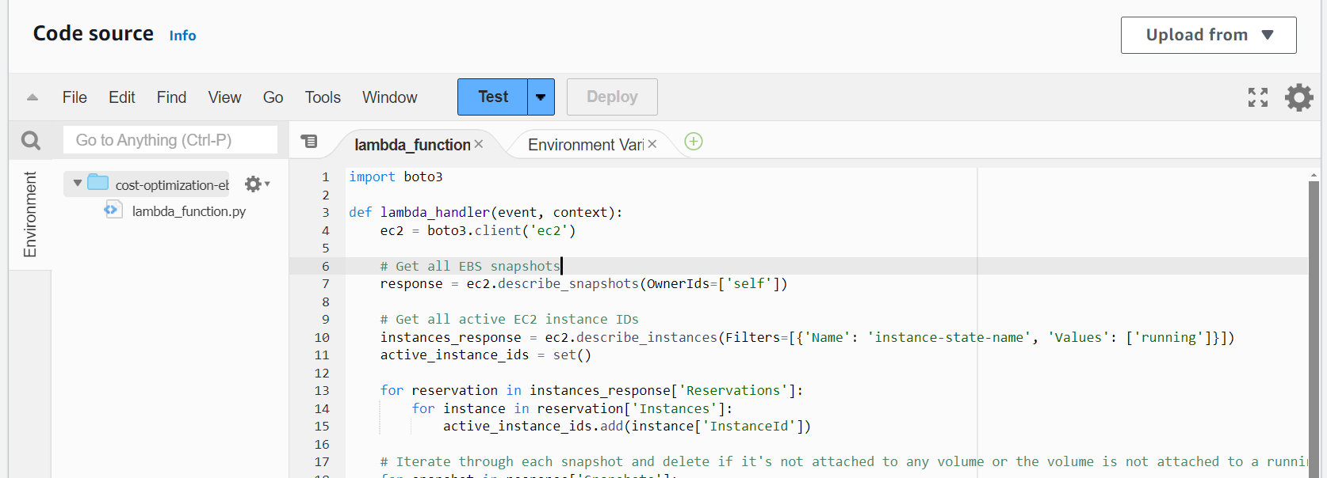

- Click Test and a pop up will open. Provide the Event name and click Save. This has been done since Lambda function will be triggered manually and not by any other AWS service such as Cloudwatch.
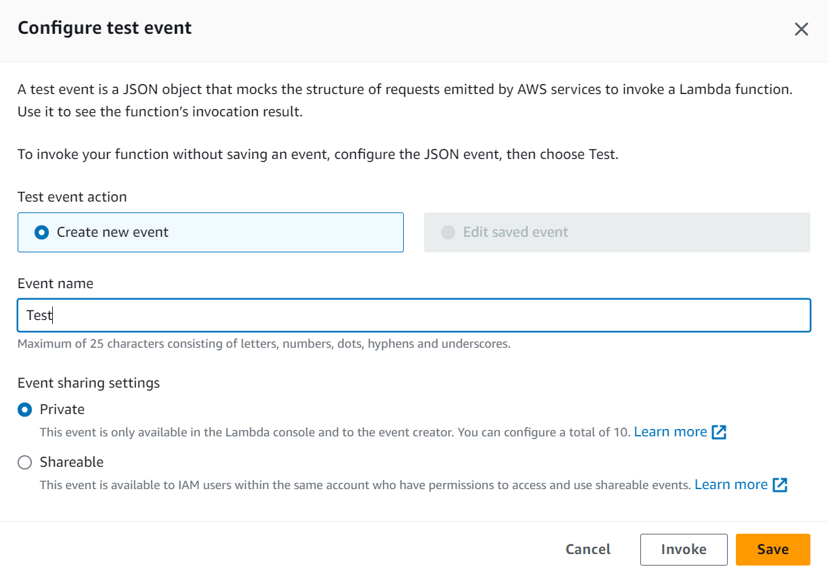
- Click Test. The Lambda function execution failed because the default execution is only for 3 seconds
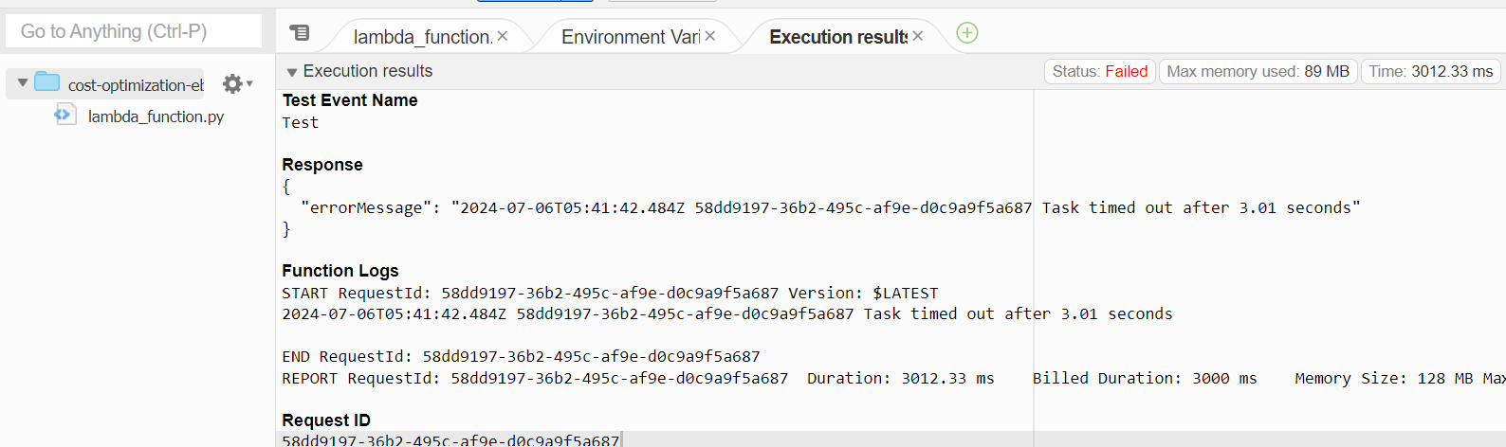

- Go to Configuration and change the default execution time to 10 sec
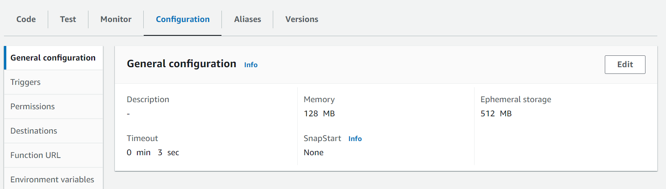
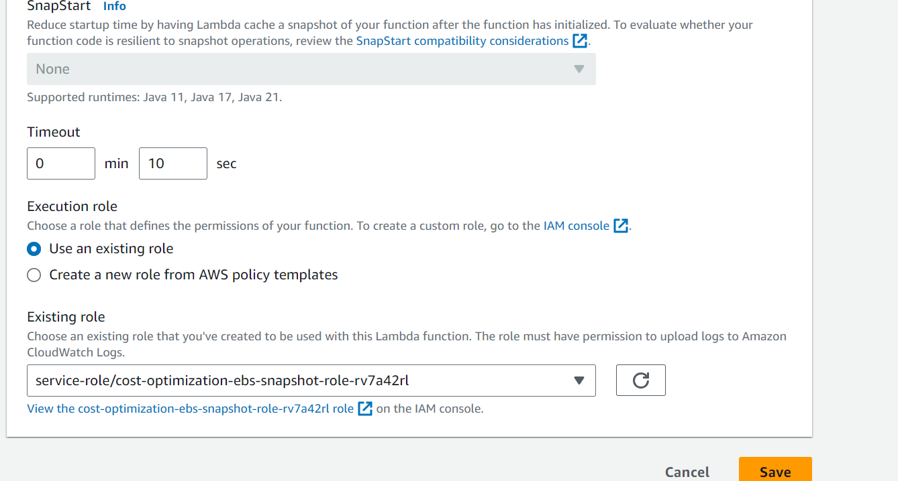
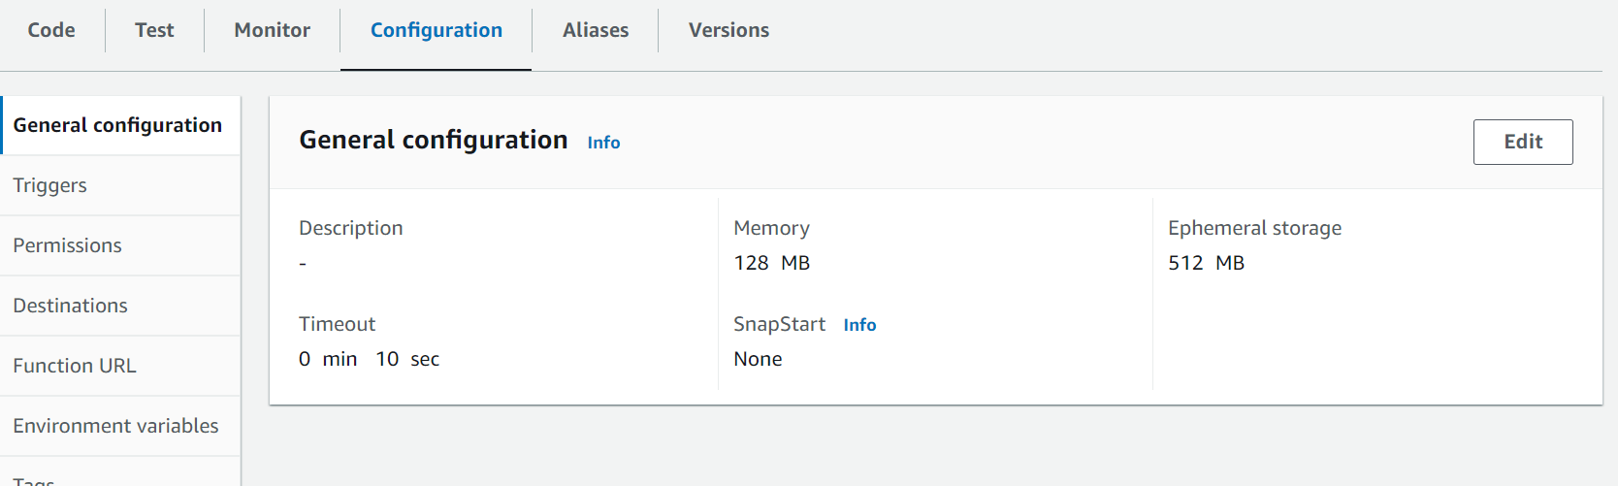

- Click Test again. The Lambda function execution failed because it has not been assigned DescribeSnapshots permissions to interact with EBS Snapshots

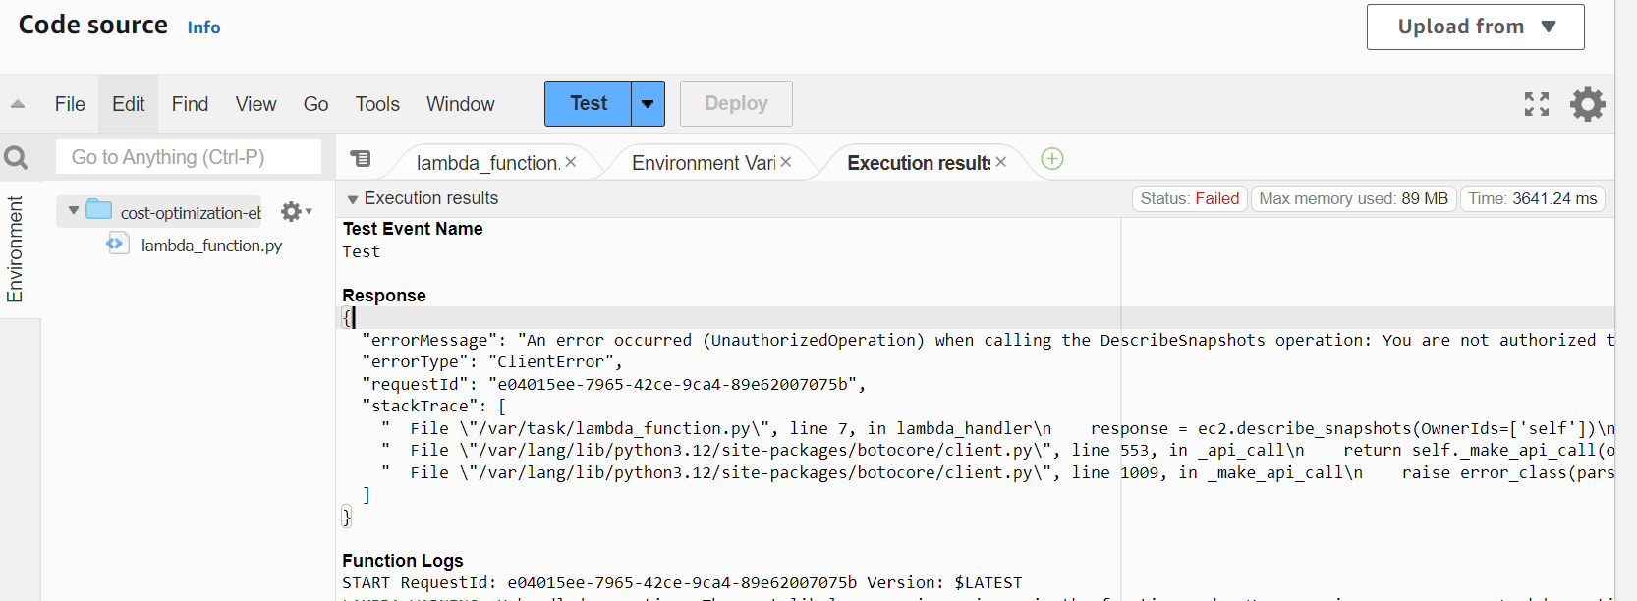

- Go to Configurations -> Permissions and click on Role name. Add permissions to describe and delete the snapshots
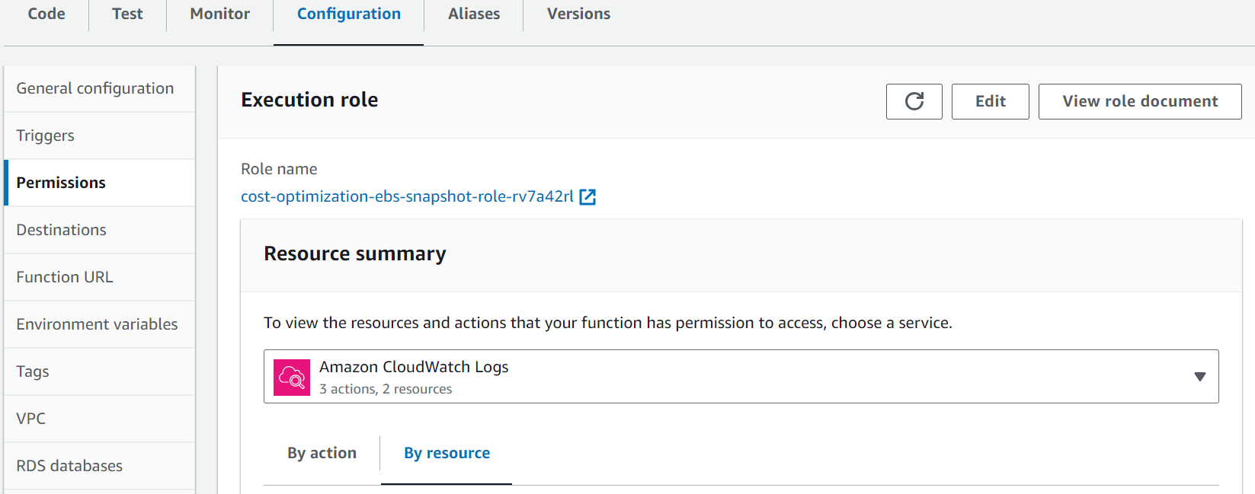
- IAM view of that role will open. Click on Add permissions and Attach policies
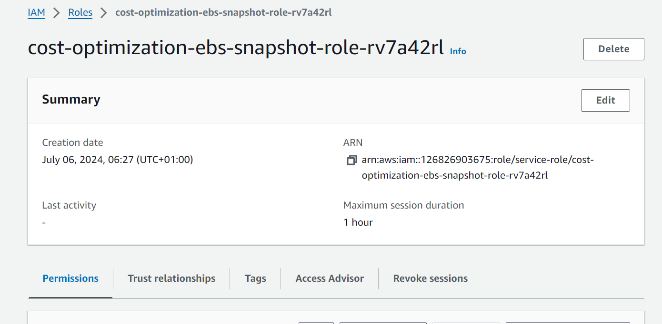
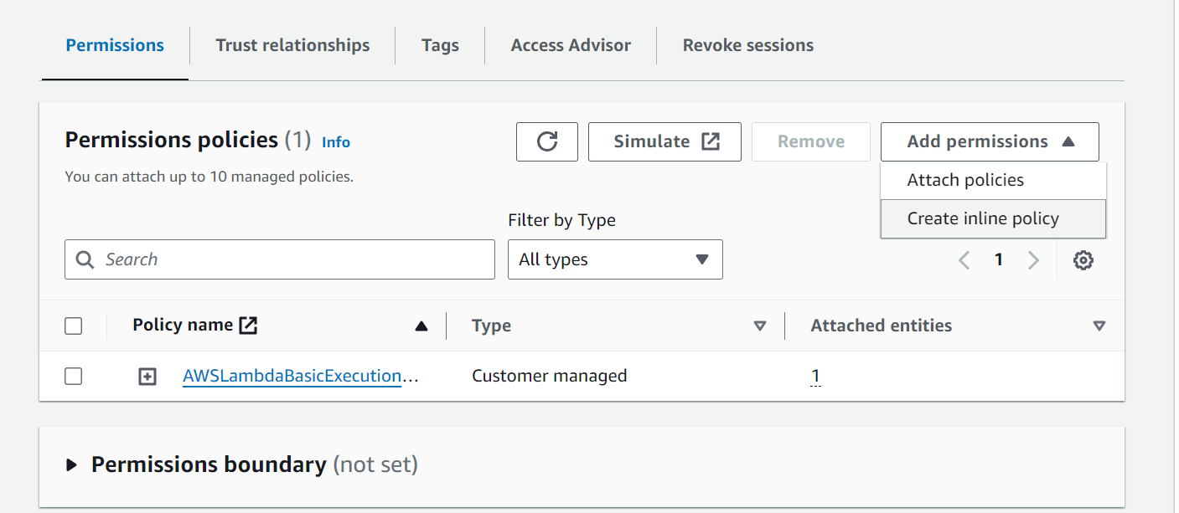
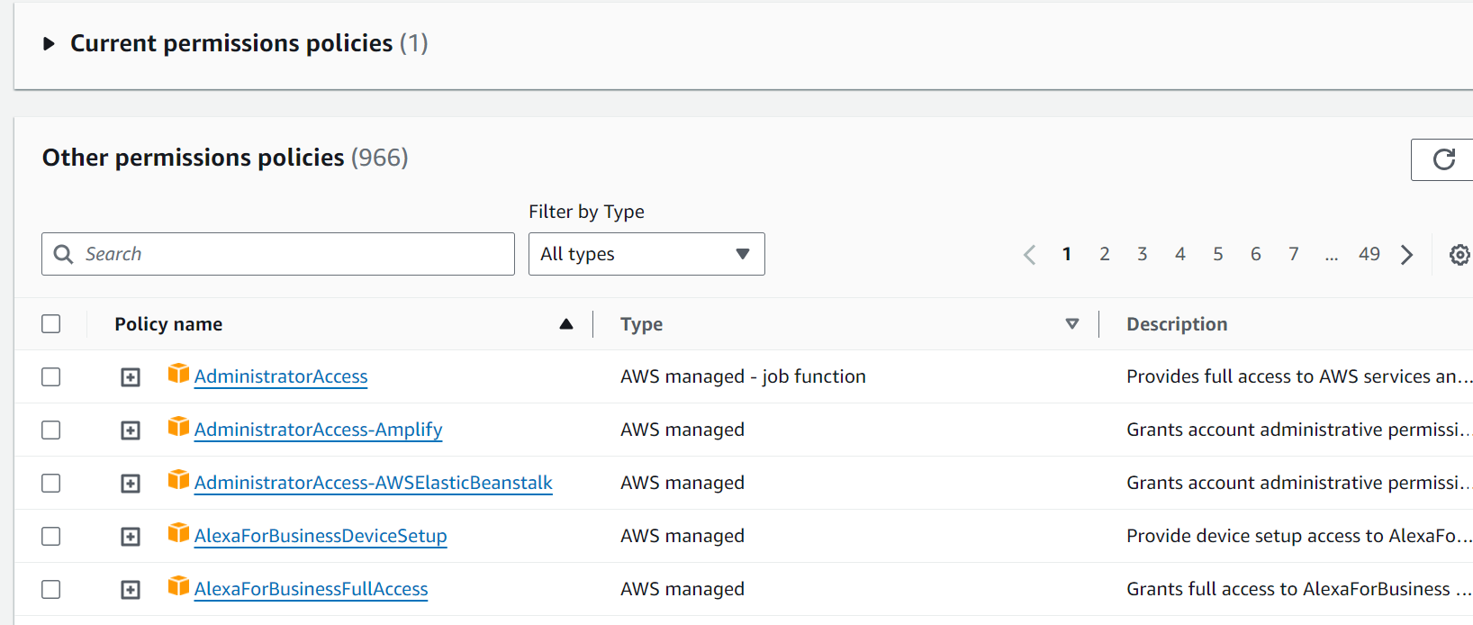

- Search by snapshot in the Search box. You will not find the default permissions to attach to the Lambda function
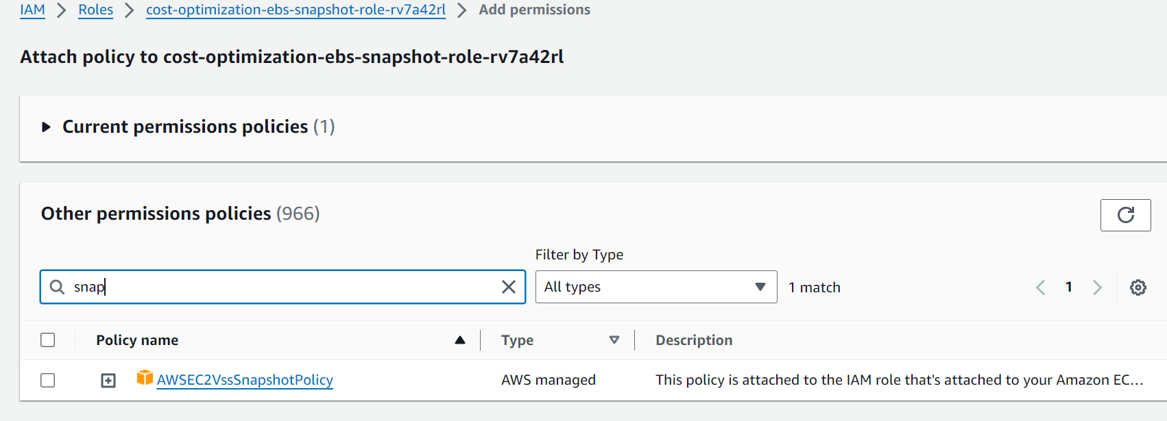
- Since a default policy could not be found, go to Create policy and select service as EC2
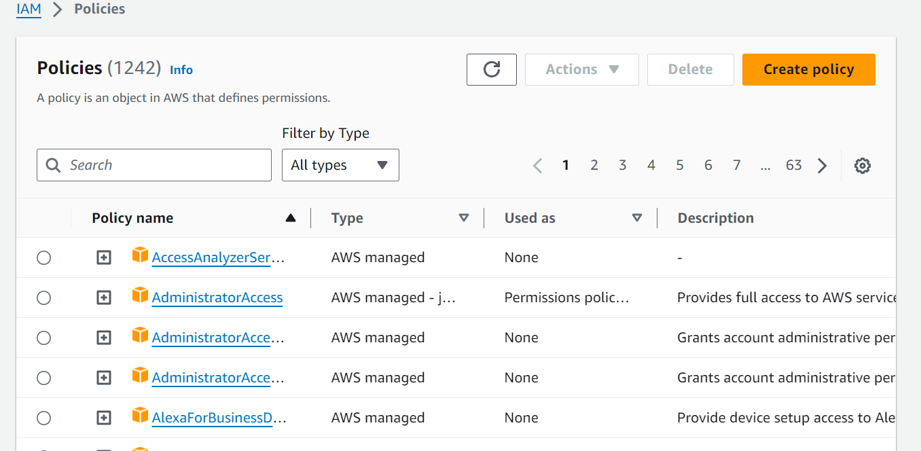
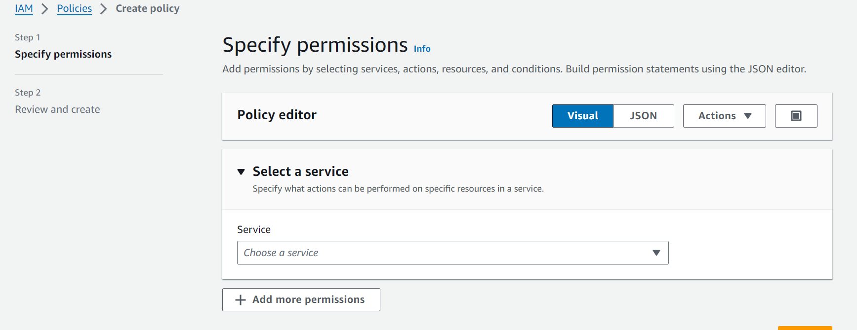

- Select service as EC2 and search actions related to snapshot. Select Describe Snapshot and Delete Snapshot. Click Next and click Create policy
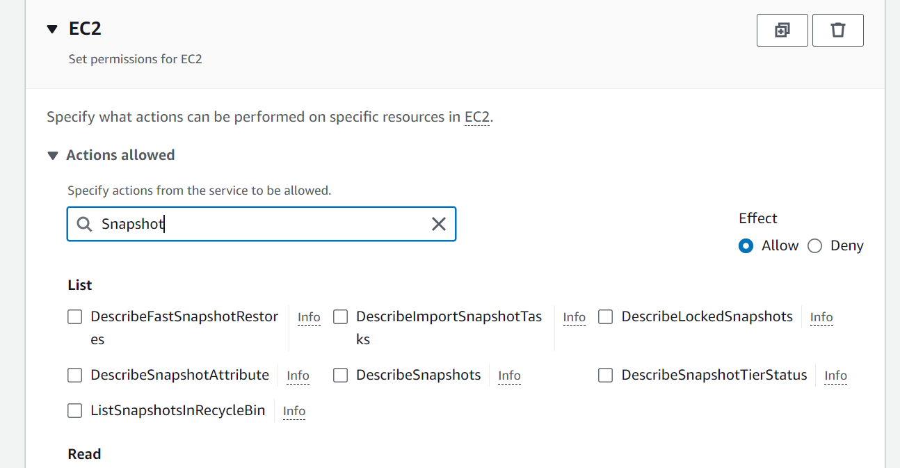
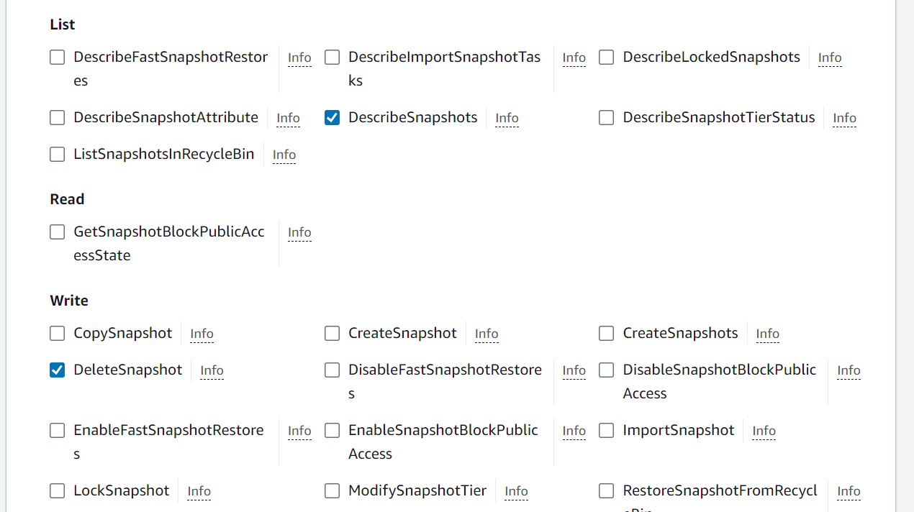
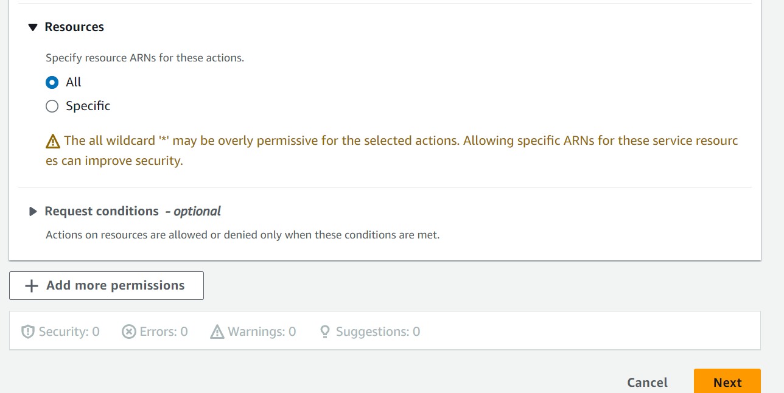
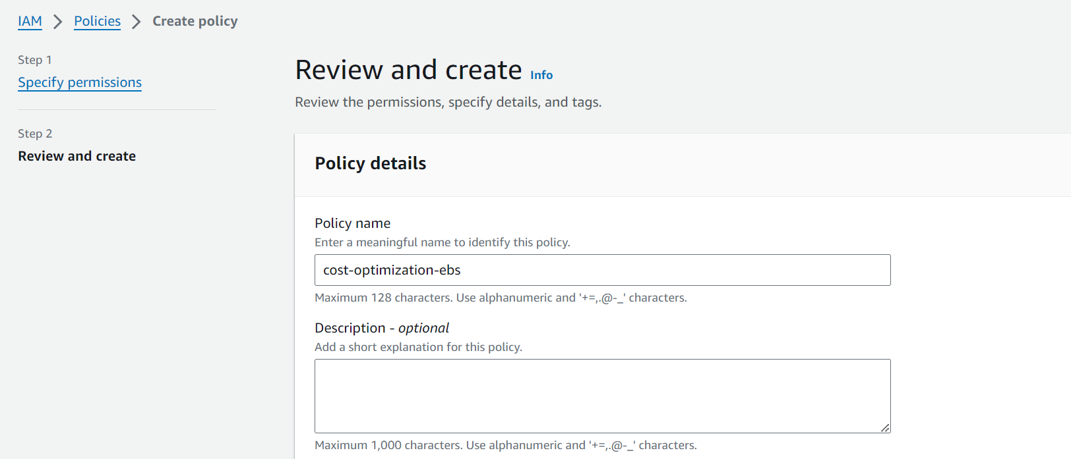
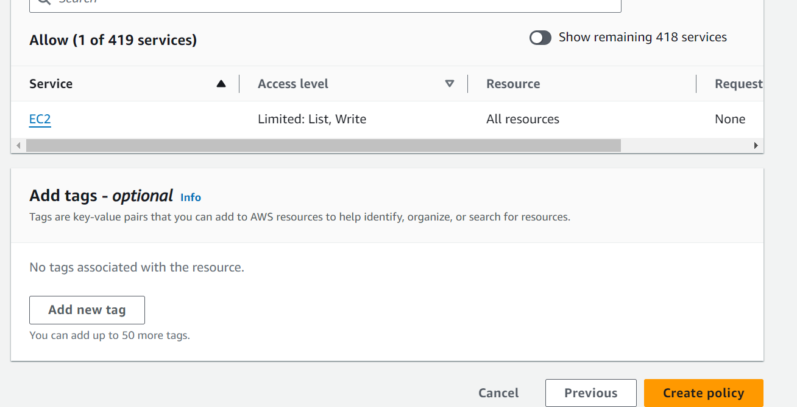

- The policy has been created. Now go back to the role and attach the policy.

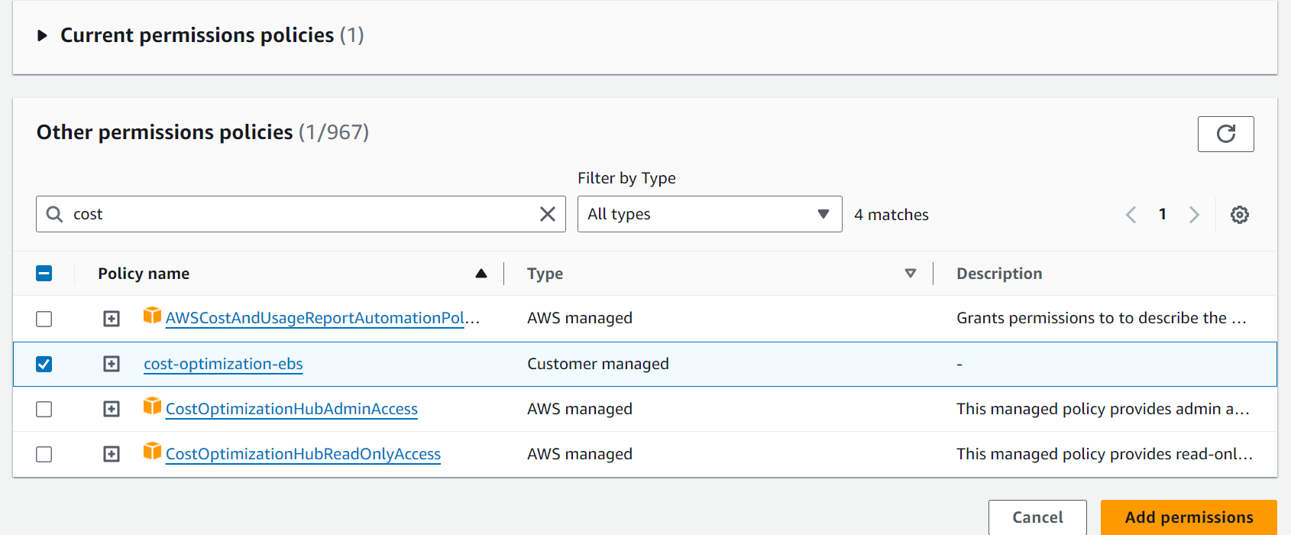
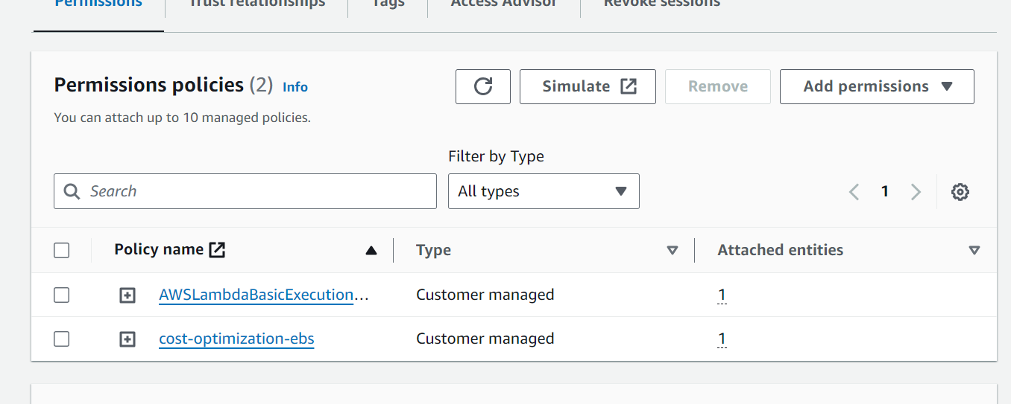

- Go back and Test the Lambda code again. The execution will fail because the Lambda function has not been assigned DescribeInstances permissions. This is because we are trying to see the snapshots which belong to the volumes which belong to EC2 instances. Hence we will have to assign DescribeInstances and DescribeVolumes
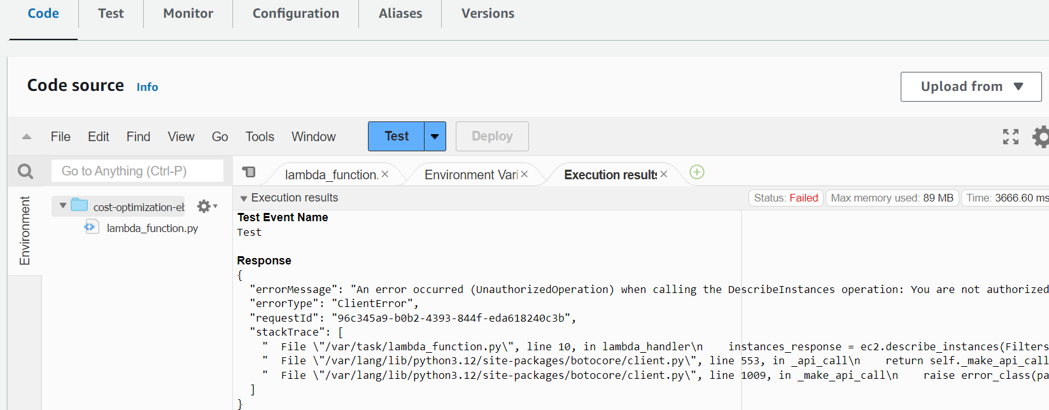
- Create policies. Go to Create policy and select service as EC2. Attach DescribeVolumes and DescribeInstances. Click Create policy

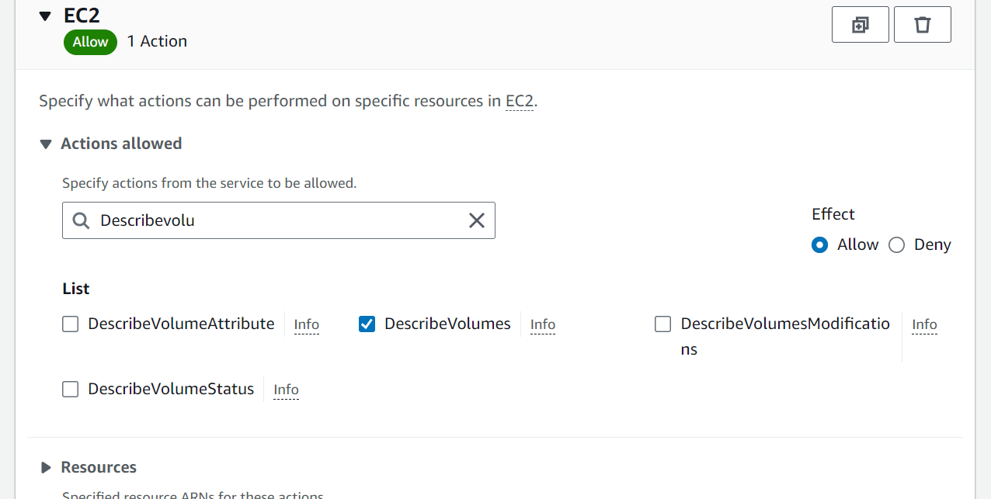
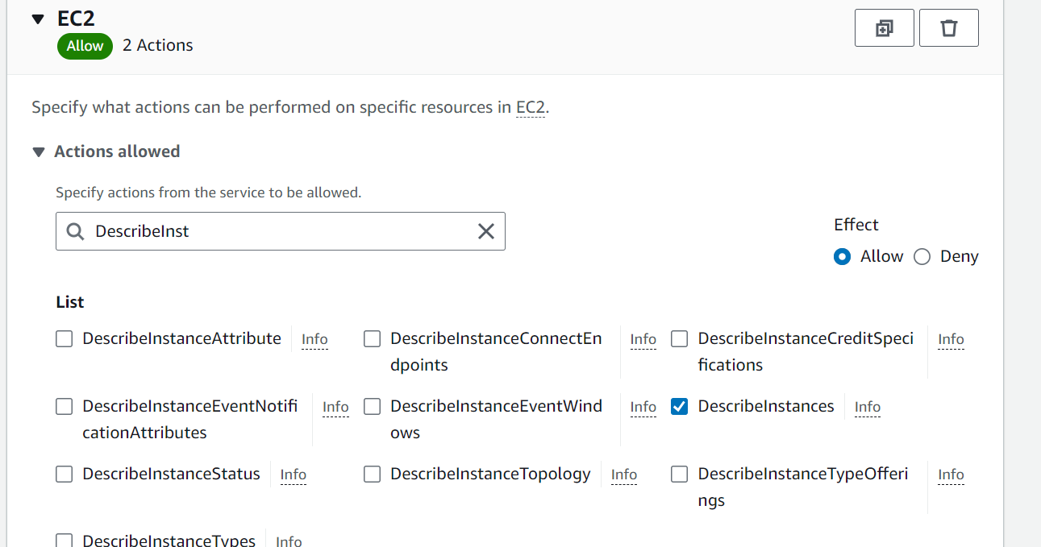
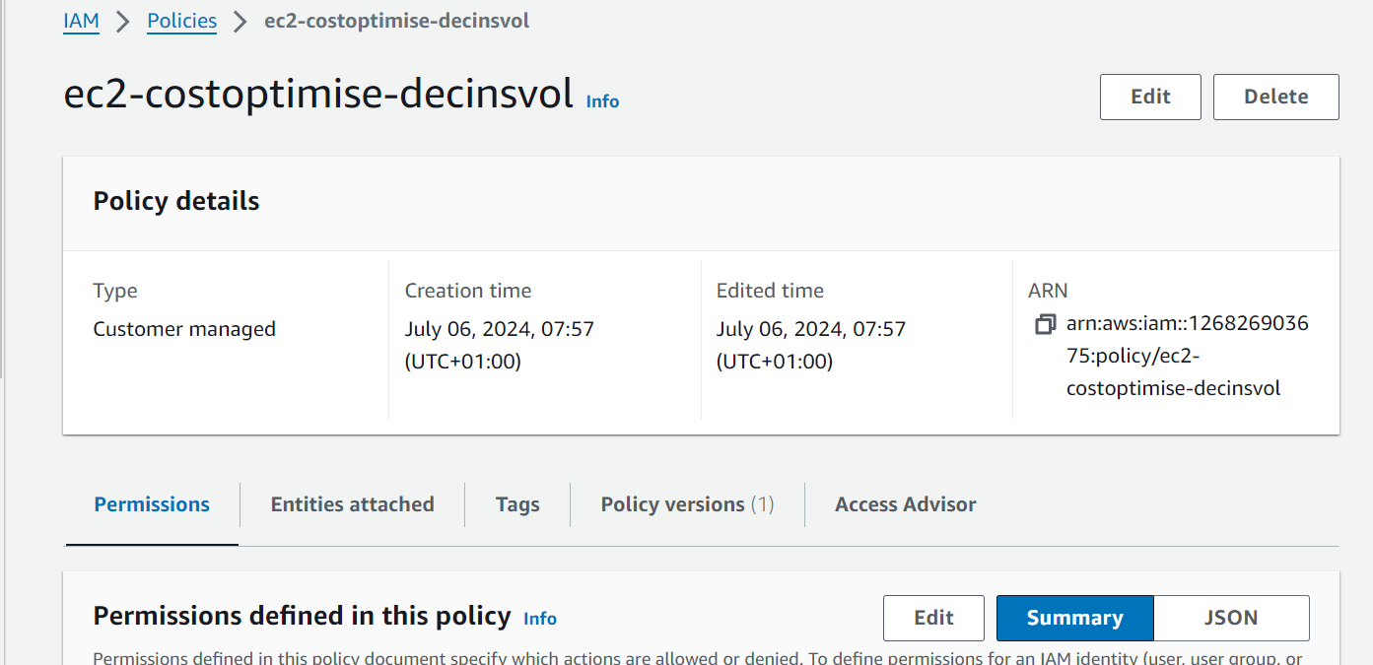

- Attach the policy to the role
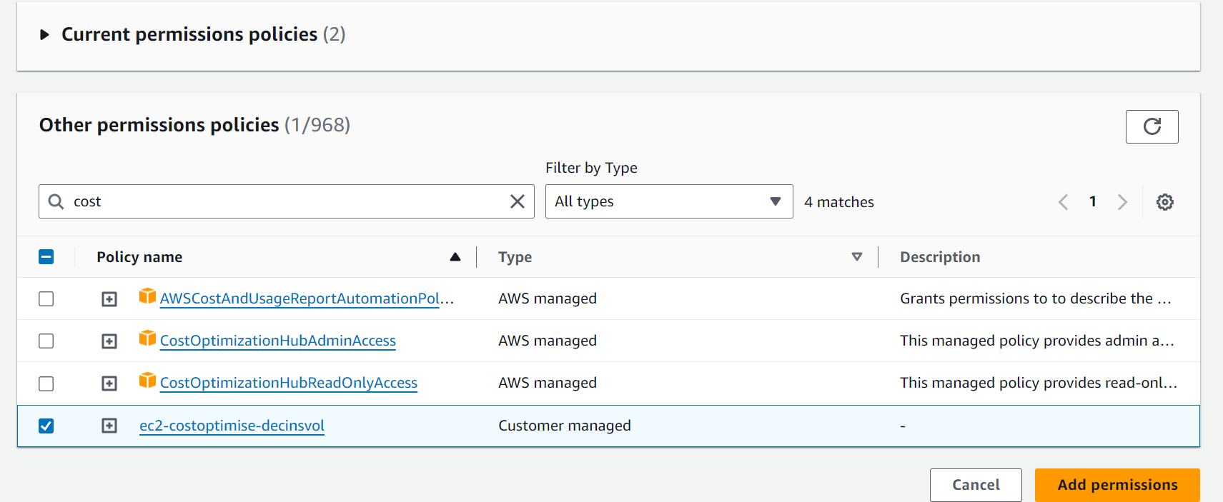
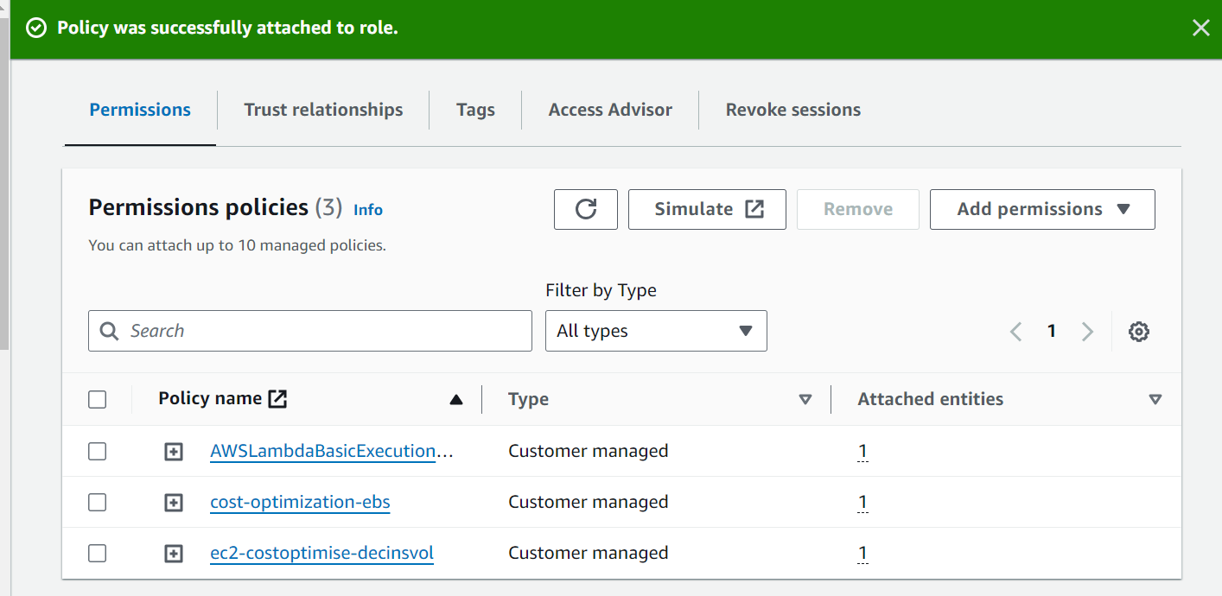
- Go back to the Lambda function and test the code again
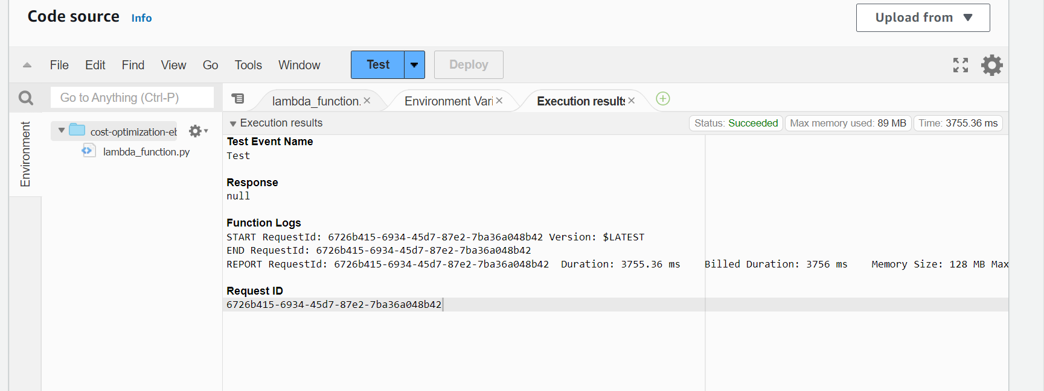
- Go back to EC2 snapshot and check if the snapshot has been deleted or not. The script did not delete the snapshot because it is related to a volume which is active and attached to an EC2 instance
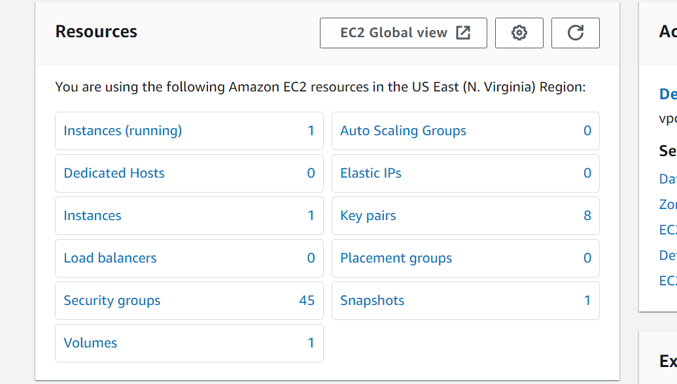

- Terminate the EC2 instance. The volume attached to it will be deleted as well
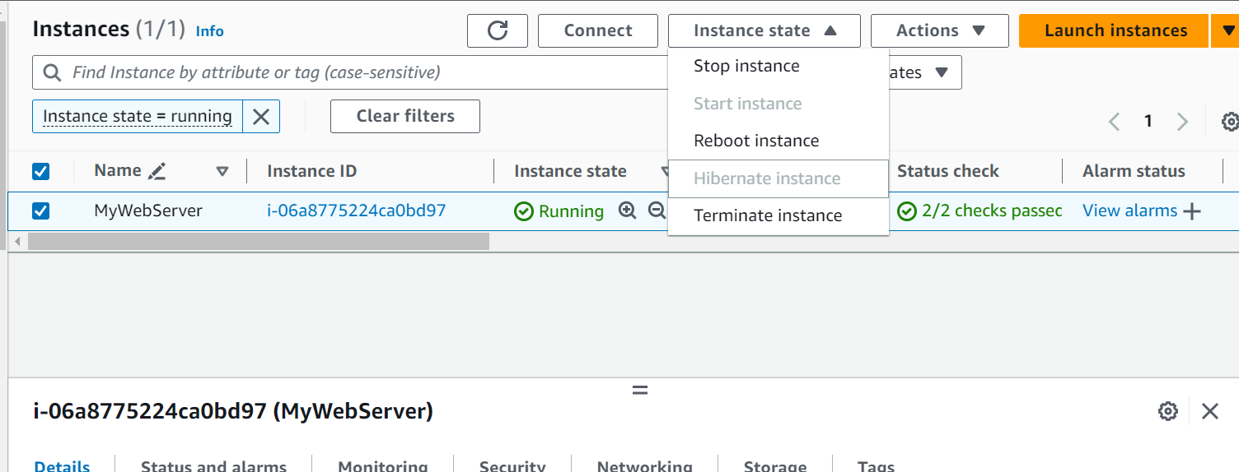

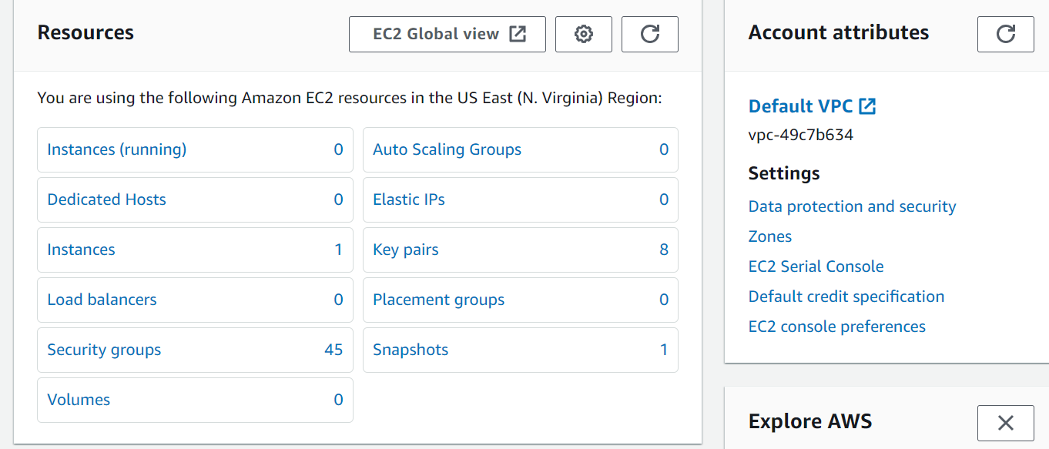

- Go back to the Lambda function and execute the code again. You will get a message as shown in the following screenshot that ‘Deleted EBS snapshot as it associated volume was not found’.
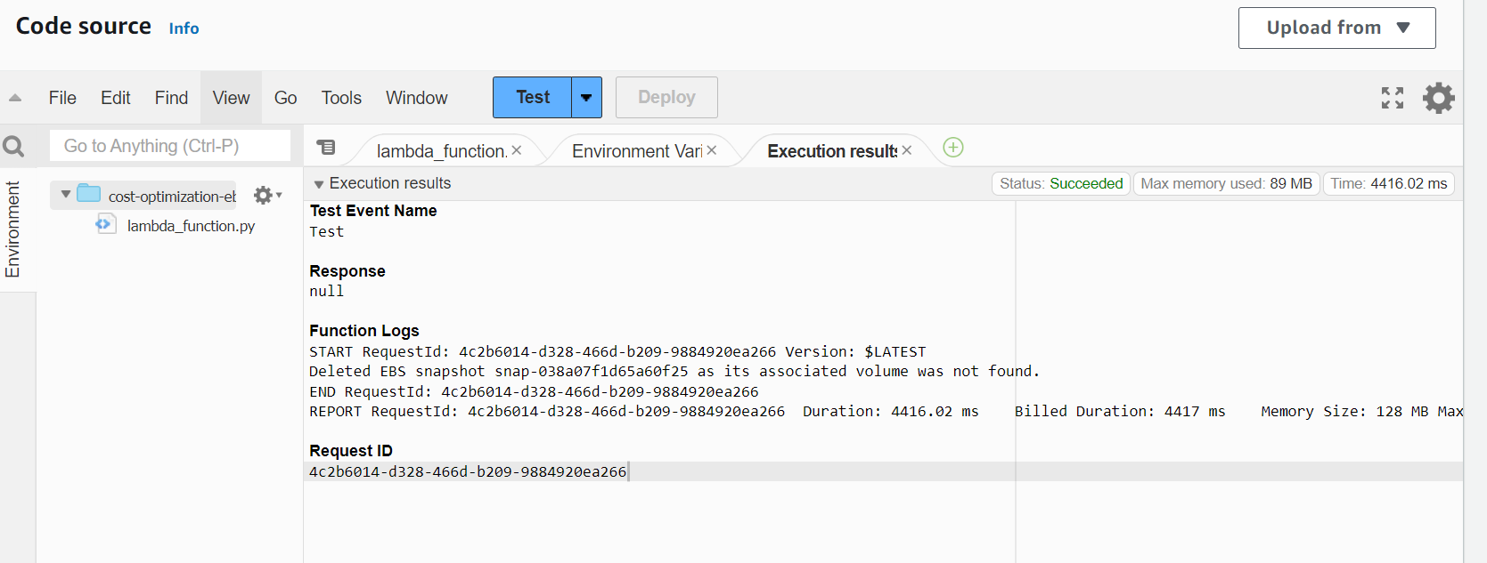

- Go back and check the EC2 dashboard. Check if the snapshot has been deleted or not. You can see in the following screenshot that it has been deleted. We can delete the snapshots based on the conditions such as if the snapshot has been created 30 days ago or if the snapshot has been used 30 days ago by modifying the script
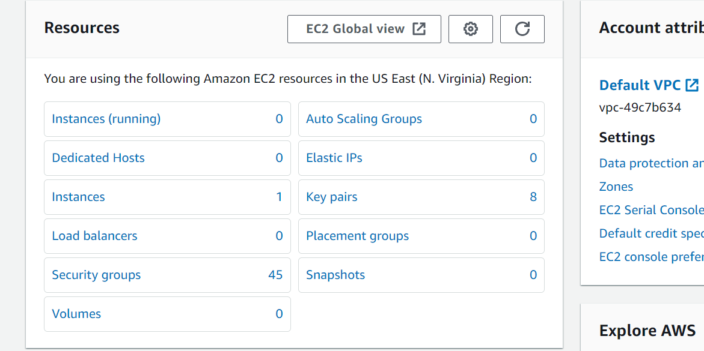

- Similarly, we can delete the hundreds of stale EBS snapshots by using the same python script. To delete stale resources such as S3 buckets, RDS instances etc; we will have to modify the script
- Create a standalone volume which is not attached to an EC2 instance and take a snapshot of that volume
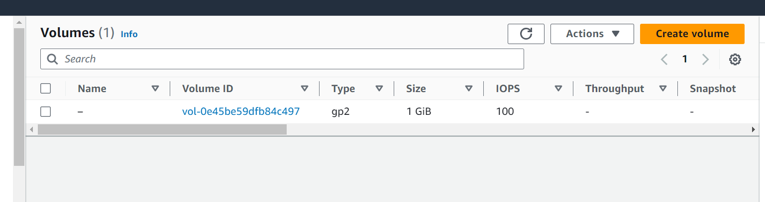
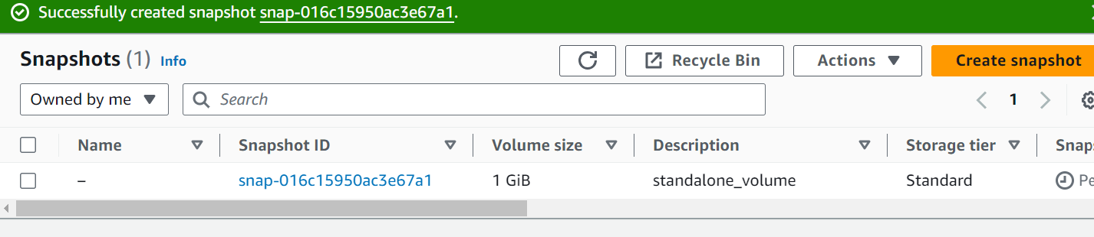

- Run the Lambda function again and check if the snapshot has been deleted or not. . You will get a message as shown in the following screenshot that ‘Deleted EBS snapshot as it associated volume was not found’.
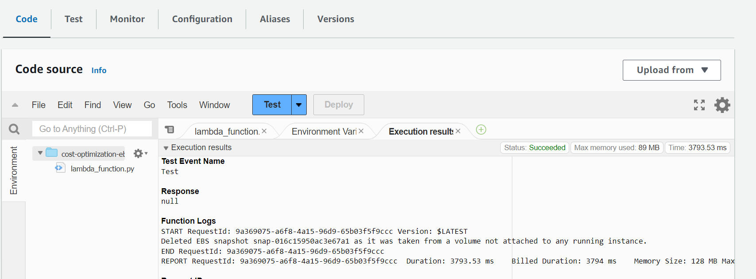
- Check EC2 Dashboard and see if the snapshot has been deleted. The snapshot has been deleted as seen in the following screenshot. This means if the volume is still active and not attached to an instance then it is possible to delete the snapshot related to that volume.
